RedHat Satellite Upgrade (from 6.13 to 6.14)

- Upgrade Helper: https://access.redhat.com/labs/satelliteupgradehelper/
- Removed and Deprecated Functionality
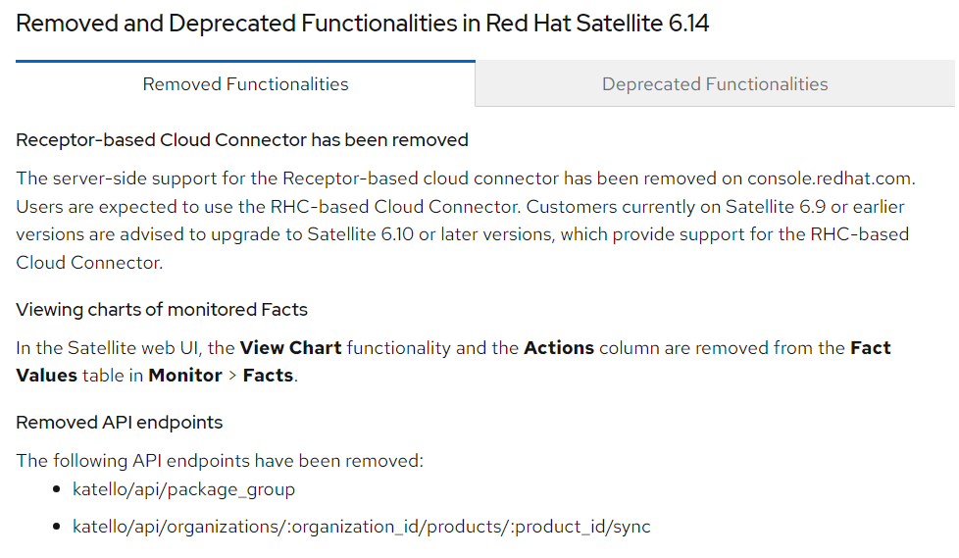
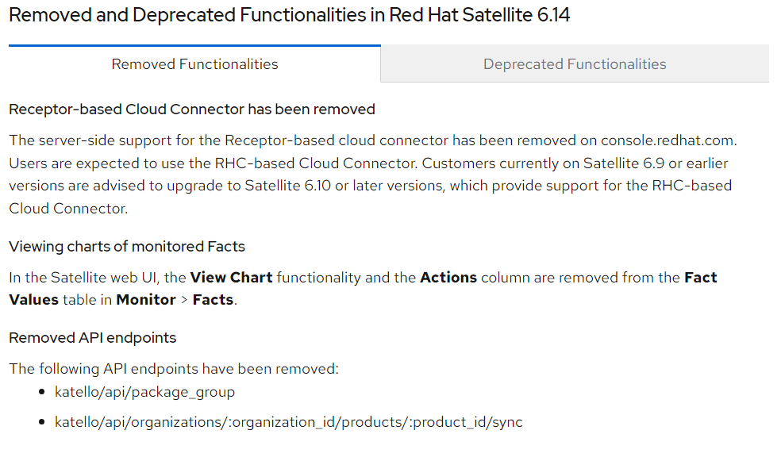
- Prerequisites
  - Storage requirements: https://access.redhat.com/documentation/en-us/red_hat_satellite/6.14/html-single/installing_satellite_server_in_a_connected_network_environment/index#Preparing_your_Environment_for_Installation_satellite
  - Ports & Firewall requirements: https://access.redhat.com/documentation/en-us/red_hat_satellite/6.14/html/installing_satellite_server_in_a_connected_network_environment/preparing_your_environment_for_installation_satellite#Ports_and_Firewalls_Requirements_satellite
- Environment check
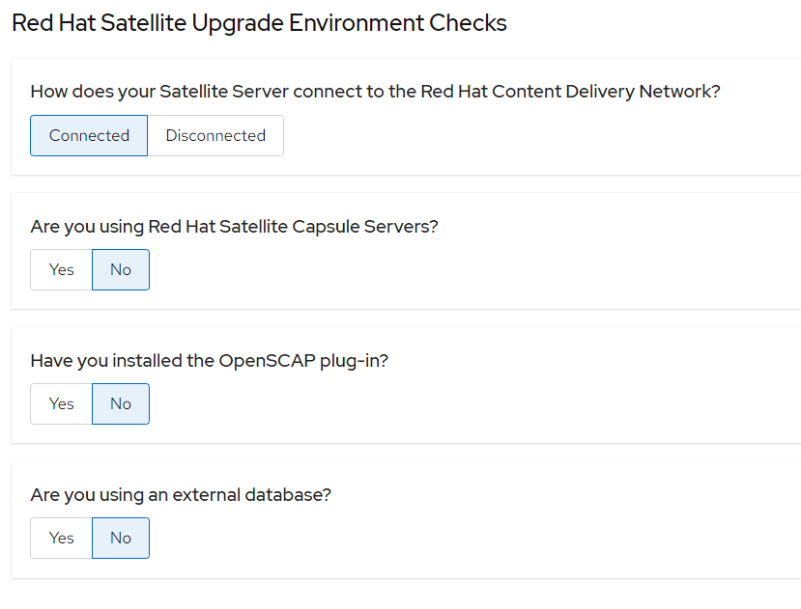
- Upgrading Satellite server:
  - Stop satellite server
# satellite-maintain service stop
  - Create a backup
    - Virtual machine snapshot
    - Clone the virtual machine
  - Ensure that the Satellite Maintenance repository is enabled:
# subscription-manager repos \
--enable satellite-maintenance-6.14-for-rhel-8-x86_64-rpms
  - Enable the maintenance mode
# dnf module enable satellite-maintenance:el8
  - Check the available versions to confirm the version you want is listed
# Satellite-maintain upgrade list-versions
  - Use the health check option to determine if the system is ready for upgrade
# satellite-maintain upgrade check --target-version 6.14
  - Perform the upgrade
# satellite-maintain upgrade run --target-version 6.14
  - Determine if the system needs a reboot
# dnf needs-restarting –reboothint
If required, then reboot the machine.
Note: Because of the lengthy upgrade time, use a utility such as tmux to suspend and reattach a communication session.

